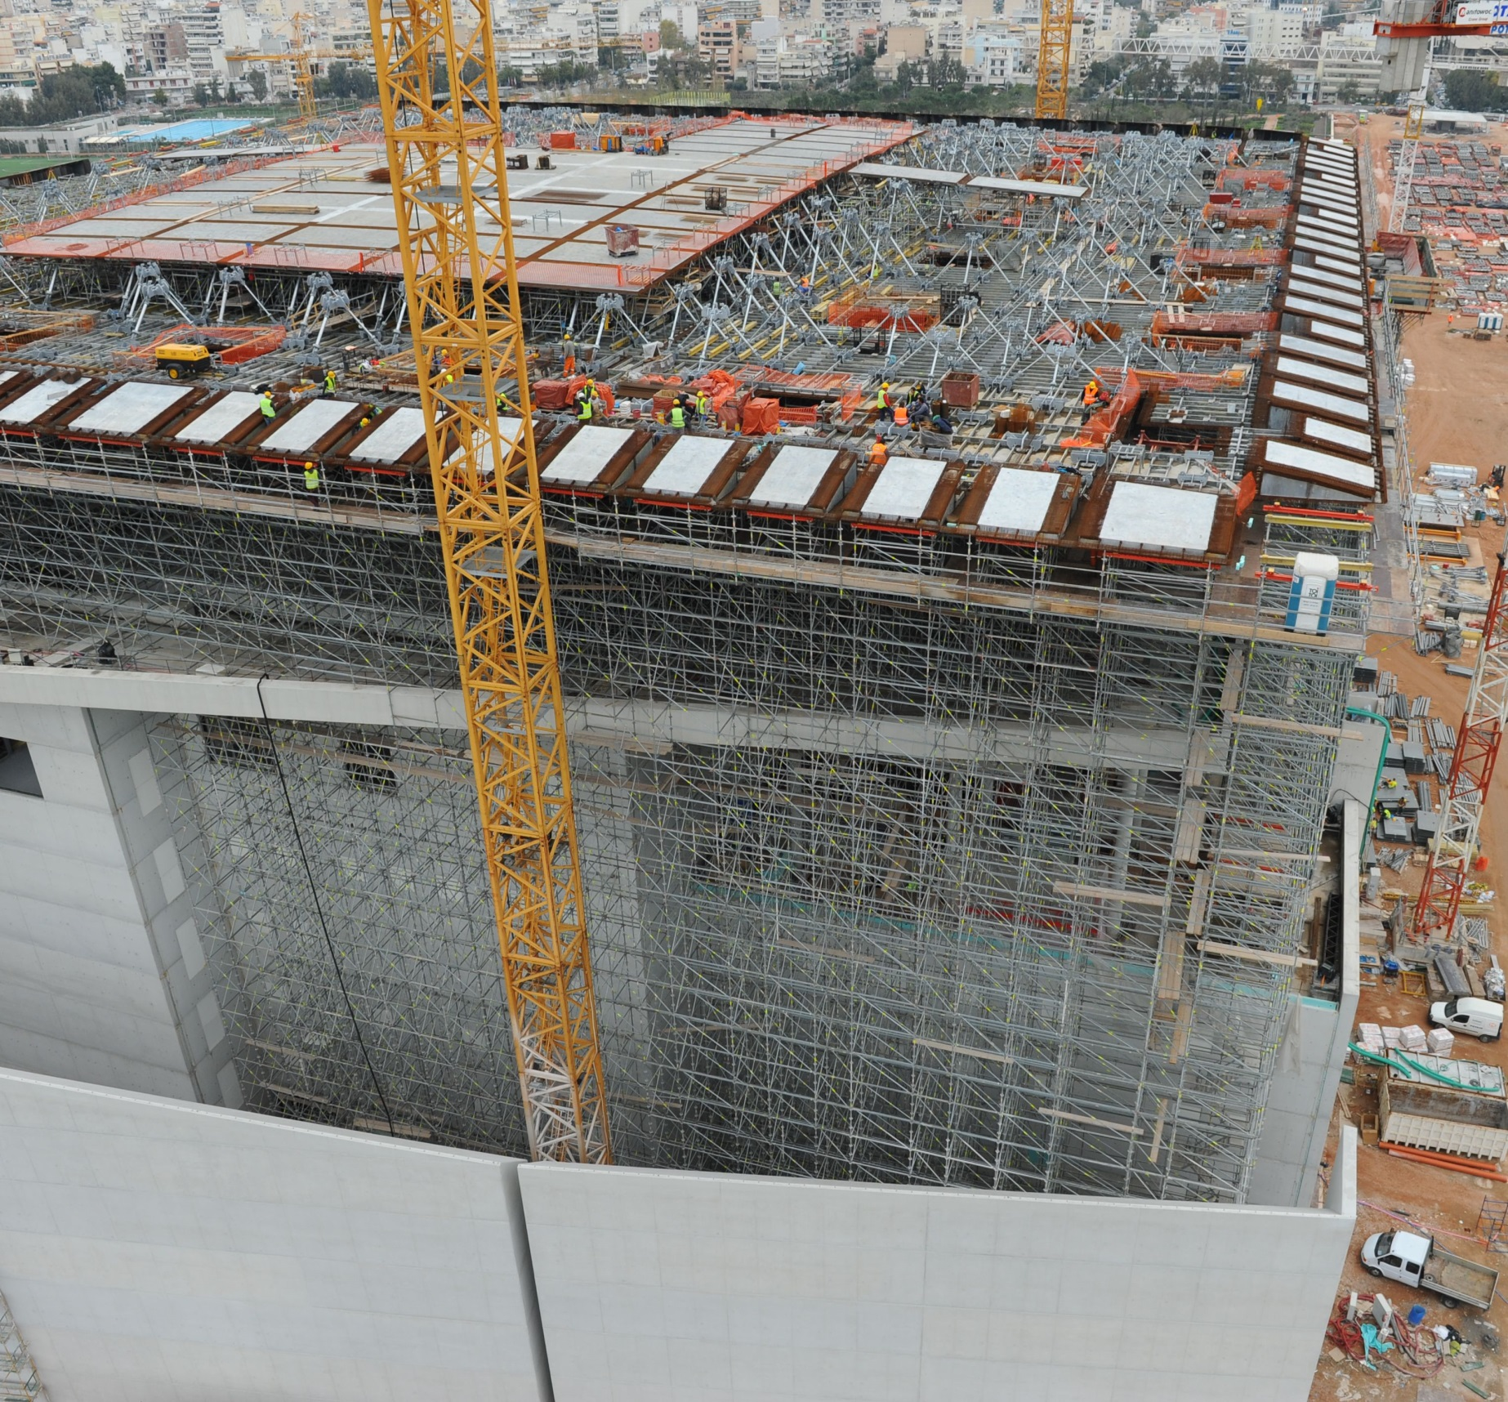

THE COMPANY

In today's complex construction environment our innovative expertise, analysis and carefully crafted approach can help bring security to construction process. AKSM implements high accuracy applications which allow us to obtain precious indications of the behavior of a structure and of the fields behaviors on which the site is situated.

By using high precision equipment, software and methologies and especially with many years of experience in the field of deformation monitoring, the company can provide results, to meet the requirements of delicate projects.

DEFORMATION MONITORING

2

Surveying Precision

3

‘Alexandros Karditsas & partners

Surveying Consulting Servises’│AKSM│

392 Mesogeion Avenue│15341 Agia Paraskevi, Athens│GREECE

T: +30 210 9702510│F: +30 213 0285617│M: +30 694 4774491

info@aksm.gr

www.aksm.gr



Deformation Monitoring

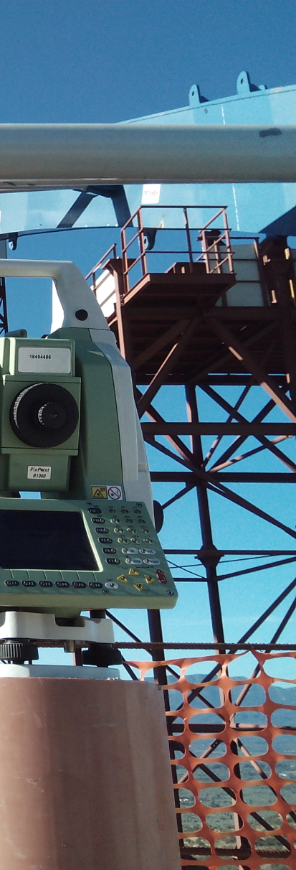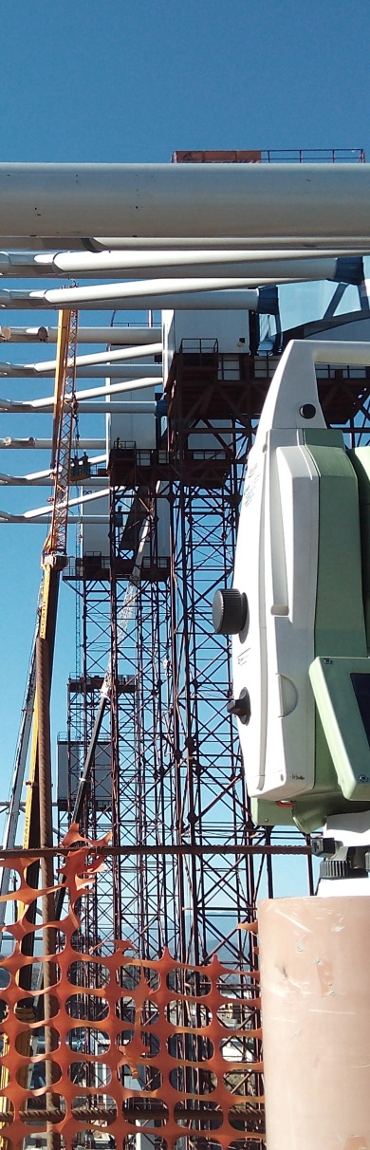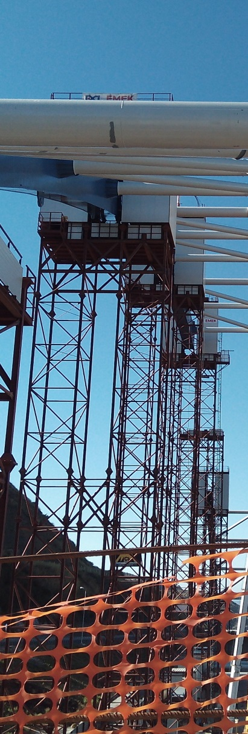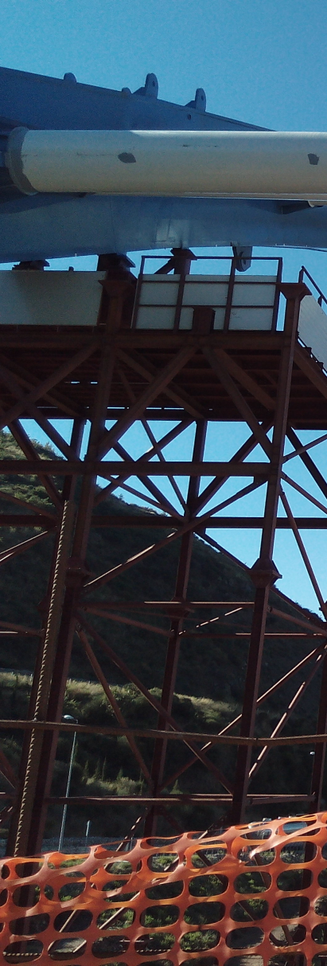

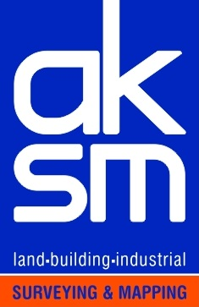

SURVEYING PRECISION

**SURVEYING PRECISION**

 ‘Alexandros Karditsas & partners Surveying Consulting Services’|AKSM│ 392 Mesogeion Avenue | 15341 Agia Paraskevi, Athens| GREECE |

SURVEYING PRECISION

www.aksm.gr

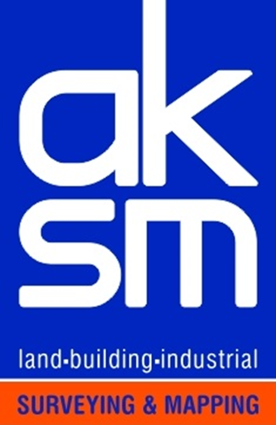T: +30 210 9702510| F: +30 213 0285617 | M: +30 694 4774491 | E-mail: info@aksm.gr